**Configuring RDP Control Settings**

**RDP Control > Settings** allows you to configure Remote Desktop Protocol (RDP) settings and display window parameters during RDP sessions. Two settings profiles (**default** and **rdp5_only**) are set by default. To create your own custom settings profile, follow these steps.  
  
**Configuring RDP Control Settings**

1. To open the Settings dialog box, navigate to **Main menu > RDP Control > Settings**.

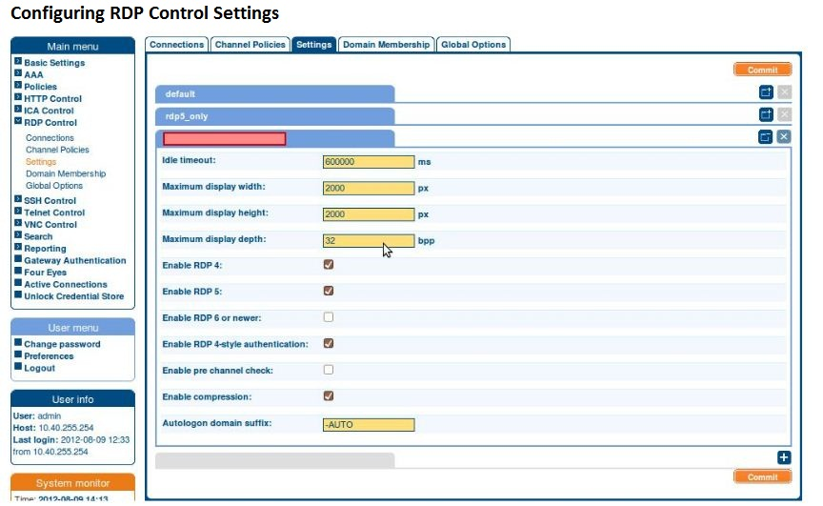

1. To create a new settings profile, click .

| TIP: To close a settings profile tab, click .

1. To name your settings profile, use the red entry field.

| TIP: Use informative names, for example, user_office_secure_1.

1. Configure the settings below:
   1. To set idle timeout, enter a value larger than 1 into the **Idle timeout** entry field in milliseconds.

| CAUTION: To avoid incorrect settings,remember to convert idle timeout value into  
milliseconds. The conversion formula is multiplying the number of seconds by  
1,000 or the number of minutes by 60,000.

Example: 1 second equals 1,000 milliseconds.  
  
| TIP: For further conversion formulae, click [here](https://www.inchcalculator.com/convert/).

* 1. To set maximum display width and height for the display window during RDP sessions, enter values larger than 1 into **Maximum display width** and **Maximum display height** entry fields in pixels.
  2. To set the preferred color depth value for the display window, enter the value of your preference ( 1 | 8 | 16 | 32 | 64 ) into the **Maximum display depth** entry field in bits per pixel.

| TIP: For information about color depth, click [here](https://en.wikipedia.org/wiki/Color_depth).

* 1. To select the RDP version of your preference, select one or more of   
     **Enable RDP 4** | **Enable RDP 5** | **Enable RDP 6 or newer** checkbox options.

| TIP: To avoid potential compatibility problems, select checkbox option **Enable RDP 4-style authentication**.

* 1. To allow an evaluation check before the connection is established, select **Enable pre channel check**.
  2. To avoid network overload during RDP sessions, select **Enable compression**.

| CAUTION: Failing to enable compression may result in network load increase by  
 up to 500%.

* 1. To change the default - AUTO autologon suffix, enter the suffix of your preference into the **Autologon domain suffix** entry field.

5. To save your custom settings profile, click .

| TIP: You can create more custom settings profiles by repeating the steps above. You can later select the custom settings profile you wish to use by navigating to   
**Main menu > RDP Control > Connections** and selecting the profile of your preference from the dropdown list.